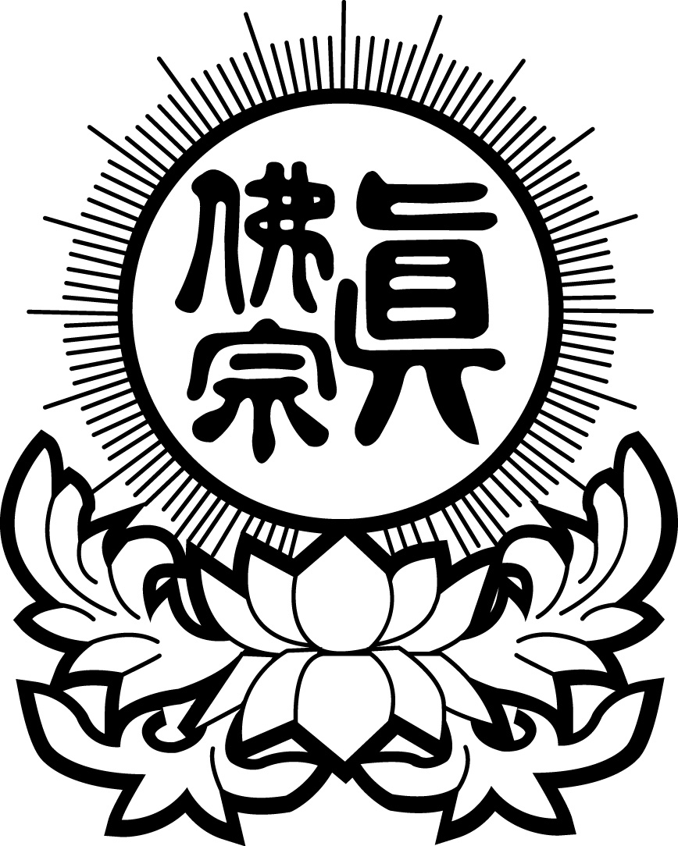
嚴 山 雷 藏 寺
YAN SHAN LEI ZANG TEMPLE
Ceremony Registration Form

Blessing Registration Date of Ceremony：___________ Title of Ceremony:_________________________
下列善信，一心至誠，虔具供養，仰叩諸佛菩薩，蓮生活佛，靈光加持，消除業障，化災解厄、身體健康、運程亨通、增福延壽、萬事如意、一切光明。伏乞慈悲虔誠是禱
Name | Age | Current Address | Purchaser ticks | Wishes
 |  |  | □Blessing Talisman
 |  |  | □Blessing Talisman
 |  |  | □Blessing Talisman
 |  |  | □Blessing Talisman
 |  |  | □Blessing Talisman
 |  |  | □Blessing Talisman
 |  |  | □Blessing Talisman
 |  |  | □Blessing Talisman
 |  |  | □Blessing Talisman
 |  |  | □Blessing Talisman
 |  |  | □Blessing Talisman
 |  |  | □Blessing Talisman
 |  |  | □Blessing Talisman

Sponsor Ceremony (As one Pleases) : $
Sponsor Flowers/Fruits Offering to Buddha (As one Pleases): $

Offering items | Unit | Number of Units | Offering Amount
Living Person Blessing Talisman | $1
Offering Buddha Set (Lotus Flower / Incense / Blessing Light) | $6
Blessing Homa Offering Wood Stick (For Living Person) | $1
 |  |  | Total：

